Screenshots or program listings must be copied into appropriate cells in the following table.
Save this evidence document as evidence_ followed by your centre number_ candidate number, for example, evidence_ zz999_9999 and insert your name, centre number and candidate number into the header above.
Examiners must be able to read the contents including any screenshots without the use of a magnifying glass. Answers that are not readable or are missing will not be awarded any marks.
Save this evidence document at regular intervals, for example every 10 minutes.
Question 1
Part 1(a)(i)
DataArray = [] # 25 elements integer

Part 1(a)(ii)
try:
with open("Data.txt", "r", encoding="utf-8") as file:
lines = file.readlines()
for line in lines:
try:
DataArray.append(int(line))
except ValueError:
print(f"Value {line} is not an integer")
except IOError:
print("File not found")

Part 1(b)(i)
def PrintArray(arr):
for i in arr:
print(i, end=" ")
print()

Part 1(b)(ii)
PrintArray(DataArray)

Part 1(b)(iii)
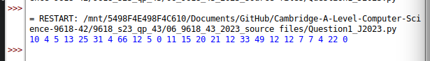

Part 1(c)
def LinearSearch(arr, search):
count = 0
for element in arr:
if element == search:
count += 1
return count

Part 1(d)(i)
while True:
try:
inp = int(input("[?] Enter a whole number [0-100]: "))
if (inp > 0) or (inp < 100):
break
except ValueError:
print("Please enter a valid number")

count = LinearSearch(DataArray, inp)
print(f"The number {inp} is found {count} times.")

Part 1(d)(ii)
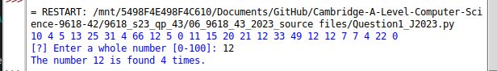

Question 2
Part 2(a)(i)
{Copy and paste program code listing for Question 2(a)(i) here}

Part 2(a)(ii)
{Copy and paste program code listing for Question 2(a)(ii) here}

Part 2(a)(iii)
{Copy and paste program code listing for Question 2(a)(iii) here}

Part 2(a)(iv)
{Copy and paste program code listing for Question 2(a)(iv) here}

Part 2(b)(i)
{Copy and paste program code listing for Question 2(b)(i) here}

Part 2(b)(ii)
{Copy and paste program code listing for Question 2(b)(ii) here}

Part 2(c)
{Copy and paste program code listing for Question 2(c) here}

Part 2(d)(i)
{Copy and paste program code listing for Question 2(d)(i) here}

Part 2(d)(ii)
{Copy and paste screenshot for Question 2(d)(ii) here}

Question 3
Part 3(a)
{Copy and paste program code listing for Question 3(a) here}

Part 3(b)(i)
{Copy and paste program code listing for Question 3(b)(i) here}

Part 3(b)(ii)
{Copy and paste program code listing for Question 3(b)(ii) here}

Part 3(b)(iii)
{Copy and paste program code listing for Question 3(b)(iii) here}

Part 3(b)(iv)
{Copy and paste program code listing for Question 3(b)(iv) here}

Part 3(b)(v)
{Copy and paste program code listing for Question 3(b)(v) here}

Part 3(c)
{Copy and paste program code listing for Question 3(c) here}

Part 3(d)(i)
{Copy and paste program code listing for Question 3(d)(i) here}

Part 3(d)(ii)
{Copy and paste screenshot for Question 3(d)(ii) here}

